EXPERIMENT 3

APPLICATION OF THEVENIN AND NORTON THEOREMS

**3.1 Objective**

In this experiment, application of Thevenin and Norton Theorems will be studied. Node and Mesh Analysis methods will be utilized.

**3.2 Equipment List**

* LTSpice

**The following equipment is for interactive online demonstration only, you will not provide them.**

* Multimeter,
* CADET,
* Carbon Resistors (two 1 kΩ, 1.8 kΩ, 3.3 kΩ, 33 kΩ,)

**3.3 Preliminary Work**

**1.**

**i.** Analyze the circuit given in Figure 1 using Thevenin theorem and calculate the Thevenin equivalent voltage (ETH) and resistance (RTH)between a and b terminals where R1=3.3 kΩ, R2=33 kΩ, R3=R4=1 kΩ

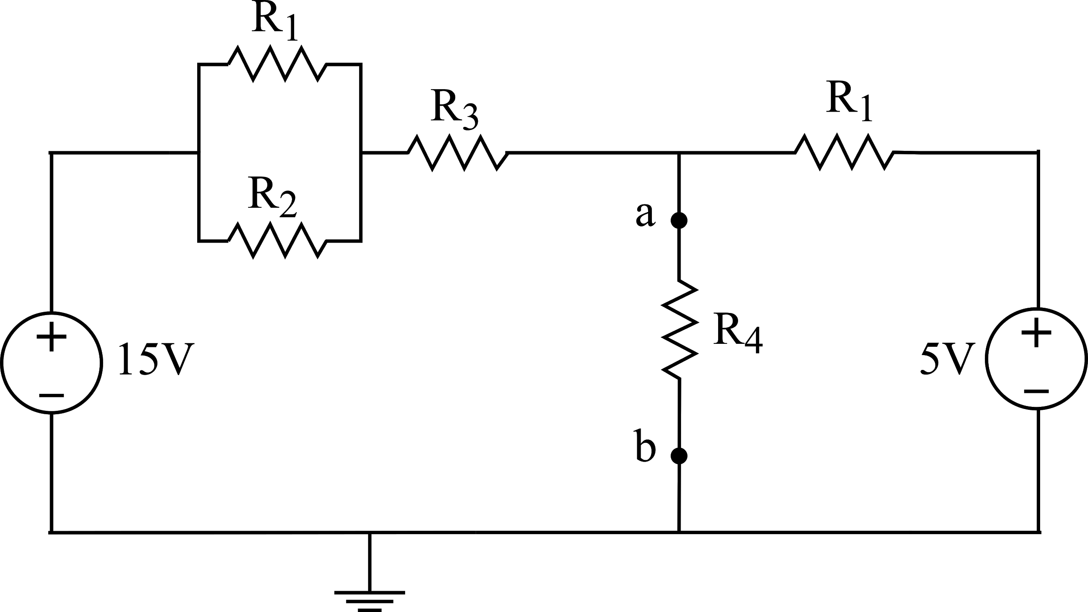

**Figure 1**

**ii.** Draw the Thevenin equivalent of the circuit in Figure 1 and calculate voltage and current values on R4**.**

**iii.** Calculate voltage and current values on R4 using Node analysis method. Compare your calculations found in *part ii*.

**2.**

**i.** Analyze the circuit given in Figure 2 using Norton theorem and calculate the Norton equivalent current (IN) and resistance (RN)between a and b terminals where R1=3.3kΩ, R3=1kΩ, R5=1.8kΩ.

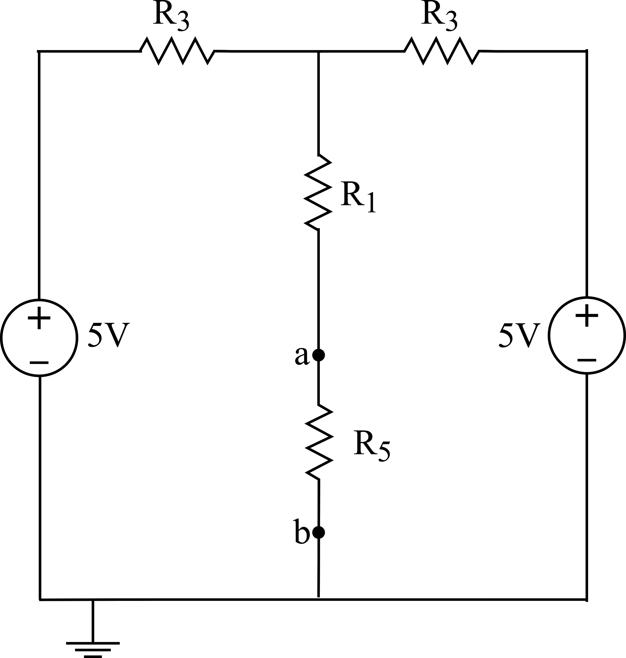

**Figure 2**

**ii.** Draw the Norton equivalent of the circuit in Figure 2 and calculate voltage and current values on R5**.**

**iii.** Calculate voltage and current values on R5 using Mesh analysis method. Compare your calculations found in *part ii*.

**3.4 Experimental Work**

Experimental work in distance education will be conducted both in the LTSpice program and in the laboratory. You will be expected to do the experimental works in LTSpice program. In the laboratory, experimental works will be conducted physically by assistants.

**1.** Set the circuit given in Figure 1 and measure the Thevenin equivalent voltage (ETH) between a and b terminals after disconnecting R4 from the circuit. (Hint: Label ‘a’ terminal in LTSpice and make DC operating point simulation, also in this circuit Vab=Va. Note: Figure 3 is provided for the experiment demonstration.)

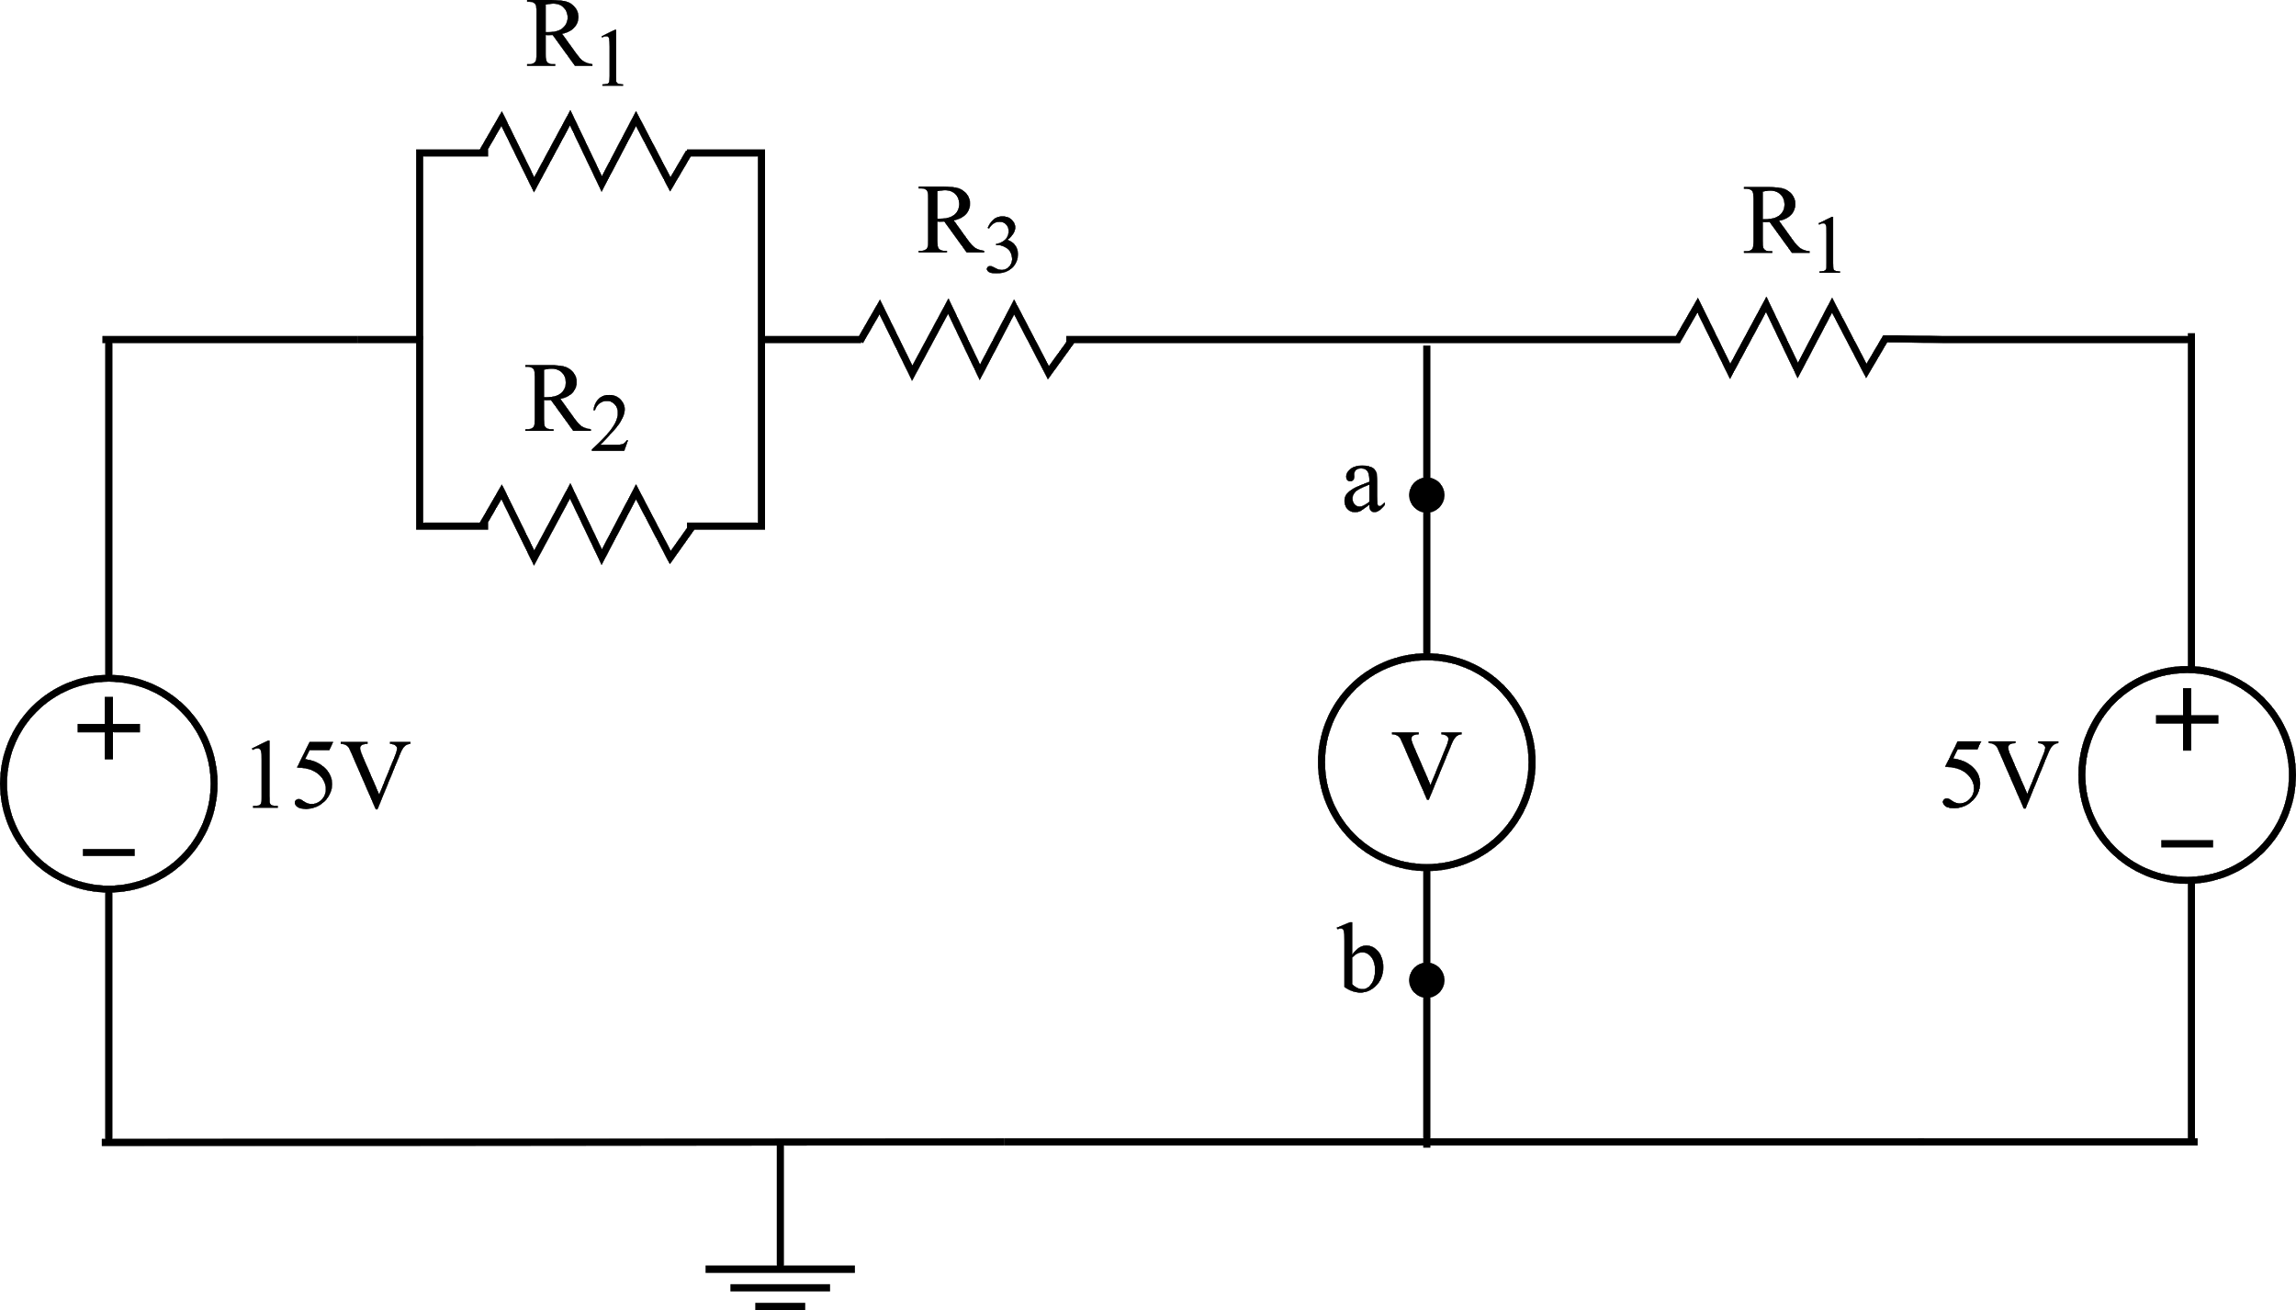be

**Figure 3**

**2.** Set the circuit given in Figure 1 and measure the Thevenin equivalent resistance (RTH) between a and b terminals. (Hint: use a very small resistor value between a and b terminals to measure short circuit current (Isc) and then calculate RTH by using open circuit voltage (Voc) obtained in the previous step and short circuit current (Isc). Note: Figure 4 is provided for the experiment demonstration.)

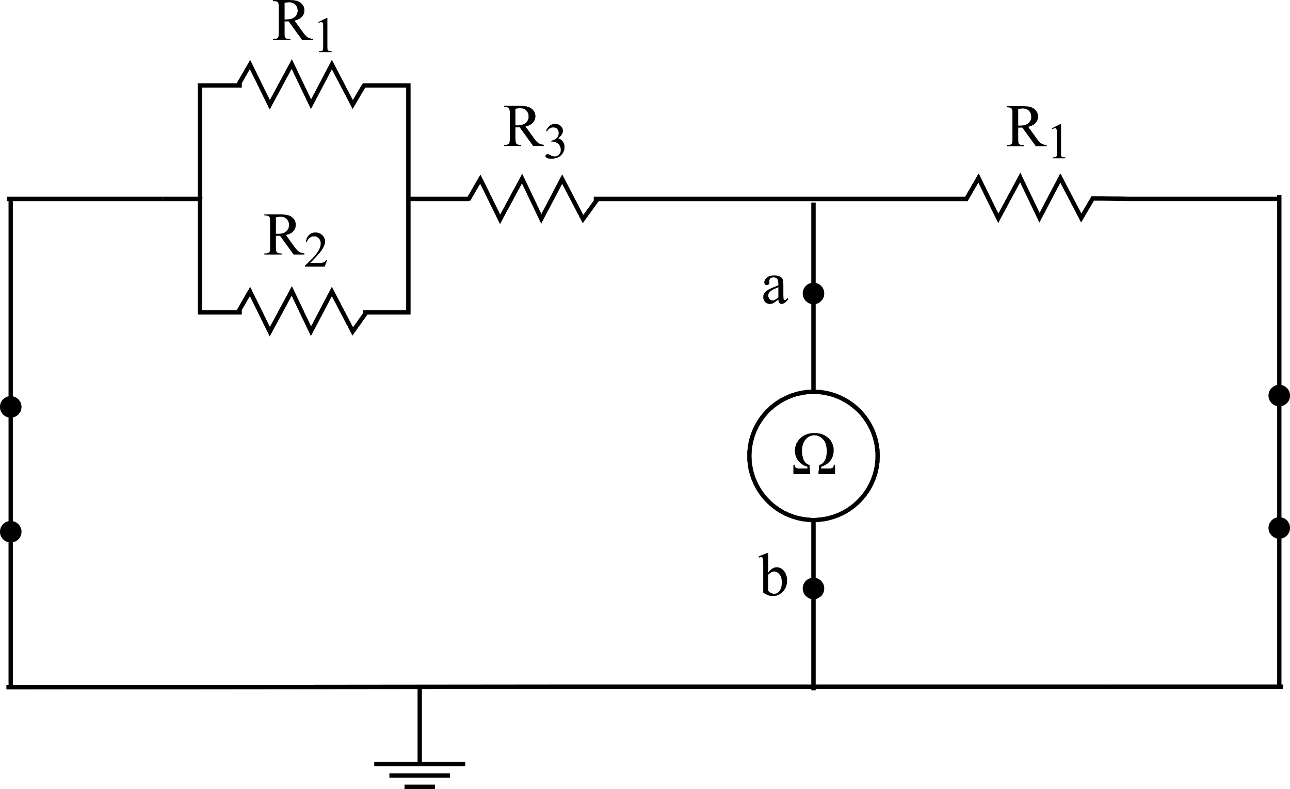

**Figure 4**

**3.** Set the circuit given in Figure 1 and measure the voltage and current values on R4. (Hint: use transient simulation.)

**4.** Set the Thevenin equivalent circuit in Figure 5 and measure the voltage and current values on R4. Compare your results with previous step.

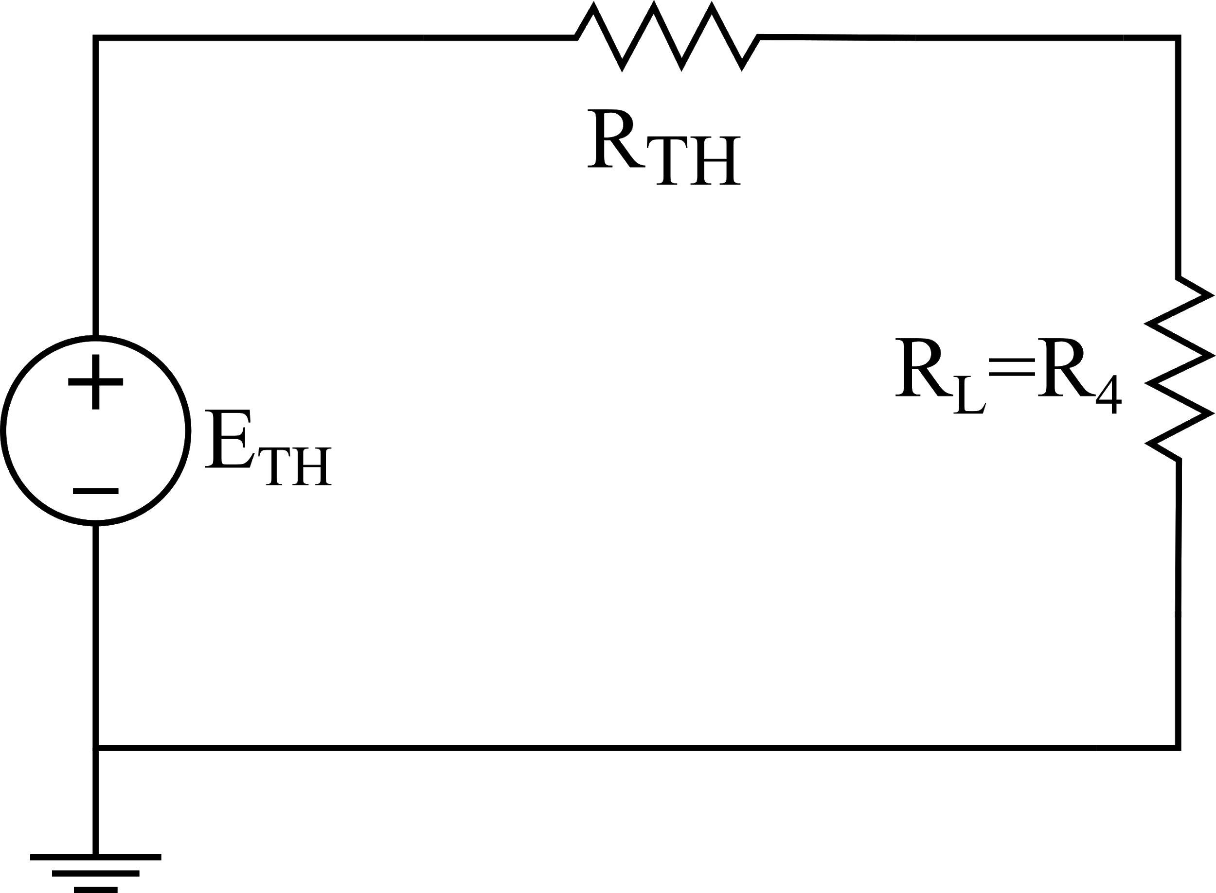

**Figure 5**

**5.** Set the circuit given in Figure 2. Measure the Norton equivalent current (IN) and equivalent resistance (RN) between a and b terminals. Compare your results with your calculations. (Hint: use a very small resistor value to measure short circuit current (Isc) and use a very large resistor value to measure open circuit voltage (Voc) between a and b terminals. Note: Figure 6 is provided for the experiment demonstration.)

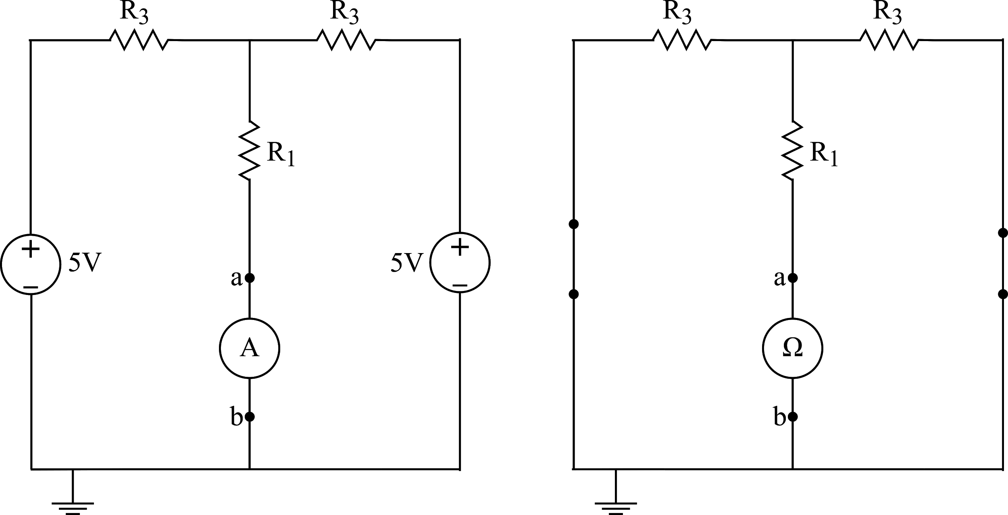

* + - 1. **(b)**

**Figure 6**

**6.** Set the circuit given in Figure 2. Measure the voltage and current values on R5. Compare your results with your calculations.

EXPERIMENT 3

REPORT SHEET

Name & Surname:

Date:

**Important Notes:**

* You will be expected to provide screenshots of your simulation results. You have to take full screenshots for all of them. You can use the full-screen mode of the Snipping Tool for this. **DO NOT crop** any image.
* If the image is too dense or too small that makes it difficult to view, then add zoomed-in images as EXTRAS (again full screenshots).
* You will name your report as “**Exp#_First/Final Report_StudentID.pdf**”

**Experimental Work:**

**1.** Take the screenshots of both circuit and DC operating point simulation results and fill the table given below with calculated and measured values.

|  |  |  |
| --- | --- | --- |
|  | **Calculated** | **Measured** |
| **ETH** |  |  |

**2.** Take the screenshots of both circuit and DC operating point simulation results and fill the table given below with calculated and measured values.

|  |  |  |
| --- | --- | --- |
|  | **Calculated in Preliminary Work** | **Measured/Calculated in LTSpice** |
| **ISC** | **X** |  |
| **RTH** |  |  |

**3.** Take the screenshots of both circuit and transient simulation results.

Voltage: Current:

4. Take the screenshots of both circuit and transient simulation results.

Voltage: Current:

**5.** Take the screenshots of both circuits and DC operating point simulation results and fill the table given below with calculated and measured values. Compare your results with your calculations.

|  |  |  |
| --- | --- | --- |
|  | **Calculated in Preliminary Work** | **Measured/Calculated in LTSpice** |
| **IN** |  |  |
| **RN** |  |  |

**6.** Take the screenshots of both circuit and transient simulation results. Compare your results with your calculations.

Voltage: Current:

**Conclusion**

**1**. Discuss experimental results from Norton and Thevenin equivalent circuits.

**2.** Compare Thevenin and Norton equivalent circuit results with your calculation and simulation results.